HACETTEPE UNIVERSITY
Department of Computer Engineering

Fuzzy Modelling
Laboratory

Furkan Simsekli
5th Semester
Turkey

Academic Year 2023/2024

Exercise 1

Write a script to draw triangular membership functions, which are described by the following mathematical relationships:

R = [-8, 7] DS = 0.2
C1 – green C2 – red

Draw the membership functions µ_{A}(x) and µ_{B}(x) on one graph in the range of R. Use a DS discretization step and the following colors µ_{A}(x) – C1 and µ_{B}(x) – C2. Determine the support and core of the fuzzy sets: support (A), support (B), core(A), core(B).

Solution

% Triangular function
x1=[-8:0.2:0]
y1=0*x1
x2=[0:0.2:3]
y2=1/3*x2
x3=[3:0.2:5]
y3=-1/2*x3+2.5
x4=[5:0.2:7]
y4=0*x4
xa=[x1 x2 x3 x4]
ya=[y1 y2 y3 y4]

x5=[-8:0.2:-6]
y5=0*x5
x6=[-6:0.2:-2]
y6=1/4*x6+1.5
x7=[-2:0.2:-1]
y7=-1*x7-1
x8=[-1:0.2:7]
y8=0*x8

xb=[x5 x6 x7 x8]
yb=[y5 y6 y7 y8]

plot(xa,ya,'g',xb,yb,'r')
grid on

% axis, line width, font size
set(gca,'fontsize',16)

text(4,0.8,'MFA','fontsize',16)
text(-1.2,0.8,'MFB','fontsize',16)

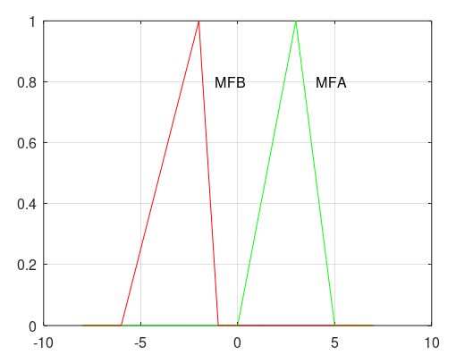
Figure 1.1: The triangular membership functions MFA and MFB

support(A) = {0.2 0.4 0.6 0.8 1 1.2 1.4 1.6 1.8 2 2.2 2.4 2.6 2.8 3 3 3.2 3.4 3.6 3.8 4 4.2 4.4 4.6 4.8}

support(B) = {-5.8 -5.6 -5.4 -5.2 -5 -4.8 -4.6 -4.4 -4.2 -4 -3.8 -3.6 -3.4 -3.2 -3 -2.8 -2.6 -2.4 -2.2 -2 -2 -1.8 -1.6 -1.4 -1.2}

plot(xa,ya,'g-o',xb,yb,'r-o')
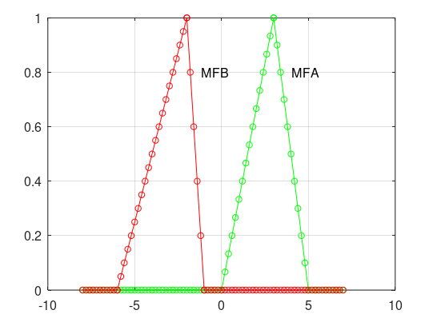

Figure 1.2: The triangular membership functions MFA and MFB for support(A) and support(B)

core(A) = {3}
core(B) = {-2}

